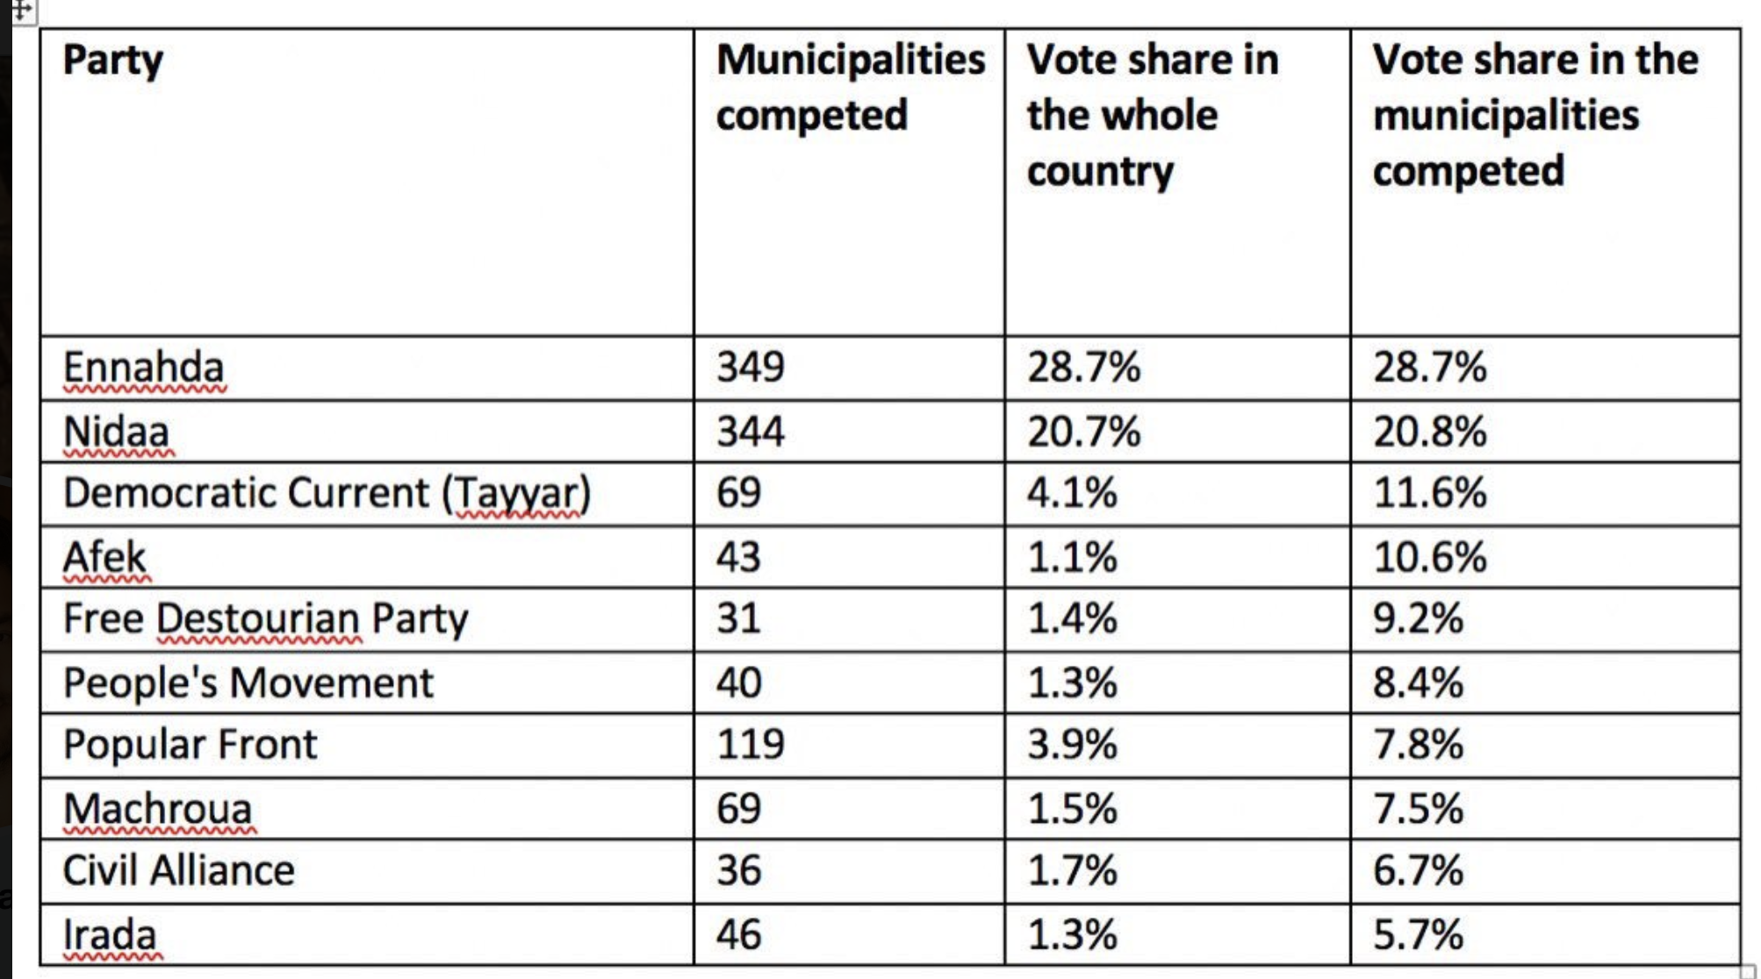

Civil Alliance members are:

Machroua; Al Jumhuri; The Democratic Movement; Afek Tounes; Al Badil; Tounes Awalan; Al Massar; Al Moubadara; Al Mustakbal; and, the party of Patriotic and Democratic Labor.

|  |  |  |  |
| --- | --- | --- | --- |
| **Affiliation** | | **Members** | |
| **2014 election results** | **As of August 2016** |
|  | [Ennahda Movement](https://en.wikipedia.org/wiki/Ennahda_Movement) | 69 | 69 |
|  | [Nidaa Tounes](https://en.wikipedia.org/wiki/Nidaa_Tounes) | 86 | 67 |
|  | [Machrouu Tounes](https://en.wikipedia.org/wiki/Machrouu_Tounes) | – | 25 |
|  | [Popular Front](https://en.wikipedia.org/wiki/Popular_Front_(Tunisia)) | 15 | 15 |
|  | [Free Patriotic Union](https://en.wikipedia.org/wiki/Free_Patriotic_Union) | 16 | 11 |
|  | [Afek Tounes](https://en.wikipedia.org/wiki/Afek_Tounes) | 8 | 8 |
|  | [Al-Irada](https://en.wikipedia.org/wiki/Al-Irada) | 4 | 4 |
|  | [Democratic Current](https://en.wikipedia.org/wiki/Democratic_Current) | 3 | 3 |
|  | [People's Movement](https://en.wikipedia.org/wiki/People%27s_Movement_(Tunisia)) | 3 | 3 |
|  | [Current of Love](https://en.wikipedia.org/wiki/Current_of_Love) | 2 | 2 |
|  | [Democratic Alliance Party](https://en.wikipedia.org/wiki/Democratic_Alliance_Party_(Tunisia)) | 1 | 1 |
|  | [Farmers' Voice Party](https://en.wikipedia.org/wiki/Farmers%27_Voice_Party) | 1 | 1 |
|  | [Movement of Socialist Democrats](https://en.wikipedia.org/wiki/Movement_of_Socialist_Democrats) | 1 | 1 |
|  | [National Front for Salvation](https://en.wikipedia.org/wiki/National_Front_for_Salvation_(Tunisia)) | 1 | 1 |
|  | [Republican Party](https://en.wikipedia.org/wiki/Republican_Party_(Tunisia)) | 1 | 1 |

|  |  |  |
| --- | --- | --- |
| **Name** | **MPs** | **% of Local Officials/vote** |
| **Major? In Parliament and at least 10% and above votes in local elections** |  |  |
| Ennahdha | 69 | 28.7% |
| Nidaa Tounes | 50-60 | 20.8% |
| Tayar/Democratic Current | 3 | 11.6% |
| Afek Tounes | 8 | 10.6% |
|  |  |  |
| **Non Major? Less than 10% vote in local elections and/or MPs** |  |  |
| Popular Front | 15 | 7.8% |
| Free Destourian Party | 0 | 9.2% |
| People’s Movement | 3 | 8.4% |
| Irada | 4 | 5.7% |
| Mashroua | 21-25 | 7.5% |
| Al Badil (Mehdi Jomaa) | 0 | ?? (waiting on data) |

Others to consider: Tounes Awalon as part of Civil Alliance – new party formed in 2017; Beni Watani new party in 2017;